Locality Wise Summary

Path : Reports >> Locality Wise Summary.

Steps to reach Locality Wise Summary:
Step 1 : Reports in Steps to reach Locality Wise Summary : Open the Reports module from the Billing Application(POS).
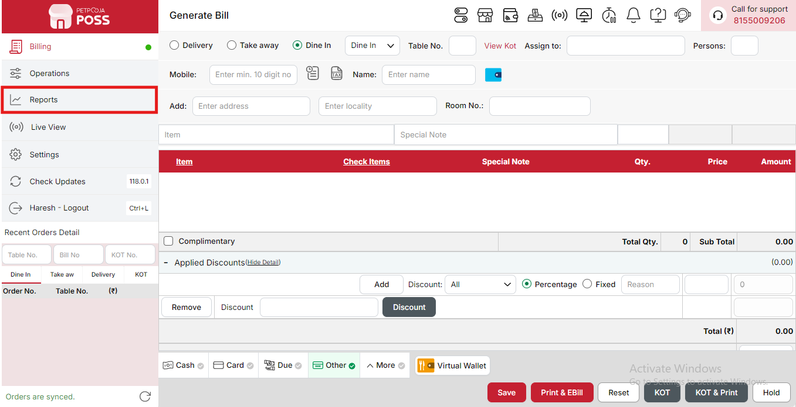
{Image Name: Reports Option,
Description: The red box highlights the “Reports” option in the sidebar menu. This section allows users to view and analyze various business reports, such as sales, billing, and order summaries, helping in effective tracking and decision-making.Here is an image of Step 1 Report in Steps to Reach Category Summary.}
Step 2 : Locality Wise Summary in Steps to reach Locality Wise Summary : Select Locality Wise Summary to view sales and order data categorized by customer localities, helping track performance across different delivery or service areas.
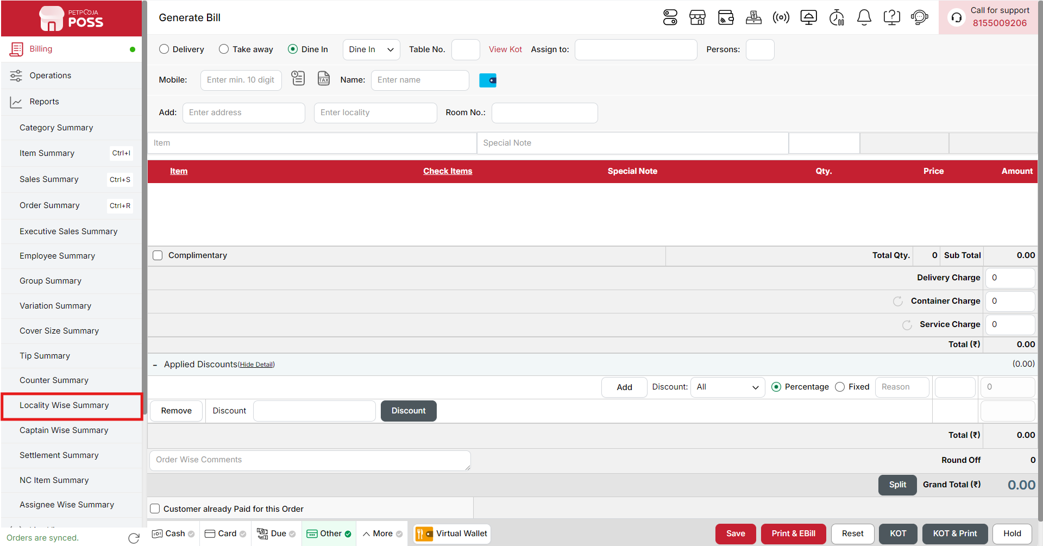
{Image Name: Locality Wise Summary,
Description: The red box highlights the Locality Wise Summary option under the Reports section. This report helps users analyze sales performance based on customer localities or delivery areas, allowing better understanding of regional demand and targeted marketing strategies.Here is an image of Step 2 Locality Wise Summary in Steps to Reach Locality Wise Summary.}

Key features of Locality Wise Summary :
(Locality Wise Summary) Note: If you are not able to see or use the Locality Wise Summary option in your billing application, it means that you do not have the required permission. To enable this, you need to go to the Owner Dashboard and open the User Management section. Inside User Management, you will find a permission called Locality Wise Summary Show Button — you must checkmark this option to give access.If you are not able to view old day reports, then you also need to enable the Days Restriction permission. Inside the same User Management section, select No Restriction so that you can view reports for any date.After allowing these permissions, perform a manual sync so the system updates the rights properly. Once the sync is done, log out from the billing application and then log in again. After this process, the Locality Wise Summary option will become visible, and you will be able to view all reports without any problem.

- (Locality Wise Summary) Locality Wise Summary: Displays a complete summary of all orders and sales amounts grouped by delivery area or locality. It helps track area-specific performance and understand customer concentration.
- (Locality Wise Summary) Locality: Locality represents the specific area or delivery zone from which an order is placed. When you add a locality in an order, it automatically appears in the locality list. If no locality is added, that order will not be shown under any locality. You can view and filter orders based on locality to track performance by area. This helps identify which regions generate more business.
- (Locality Wise Summary) Orders: Shows the total number of successfully completed orders received from each locality. This helps analyze order volume per area.
- (Locality Wise Summary) Total (₹): Displays the total revenue generated from completed orders for each locality, giving a clear view of the financial contribution of each area.
Search Button (Locality Wise Summary) : The Search button is used to find the report for a specific date or time. It helps you quickly see sales details for the selected period. After choosing the date or time, you can click on Search to view the report.
- From (Locality Wise Summary) : The From option is used to select the starting date for the locality-wise report. It means the report will begin from this date.
- To (Locality Wise Summary) : The To option is used to select the ending date for the locality-wise report. It means the report will show data up to this date.
- Time Wise Option (Locality Wise Summary) : The Time Wise Option is used when you want to see the report for a specific time period within a day. After turning it ON, you can choose both date and time — for example, from 10:00 AM to 5:00 PM — to see sales during that time. If you keep this option OFF (Without Time Wise Option), then the report will show the whole day’s data for the selected date range without filtering by time.
Configure Column (Locality Wise Summary) : Used to show or hide different columns in the report by checking or unchecking the boxes. If you want to see that option in the report, you have to check it, and if you want to hide it, you have to uncheck it.
- (Configure Column) Order: Shows the total number of orders received from each locality. You can check this to display it in the report or uncheck it to hide it.
- (Configure Column) Total (₹): Shows the total sales amount generated from each locality. You can check this to view it in the report or uncheck it to hide it.
(Locality Wise Summary) Print Button: The Print Button is used to print the report. If you want to take a printout of the report, you just need to click on the Print button.
If you get an error saying “Please assign one printer for report print”, then follow these steps:
- Go to Operation → Bill/KOT Print → Multiple Printer Settings.
- Select and edit one printer that you want to use for printing the report.
- In that printer setting, there is an option called “Use this printer for report print”.
- Check this box and save the setting.
After doing this, you will be able to print the report successfully using the selected printer.
(Locality Wise Summary) Print Configuration: This section is used to set how your report will look when you print it. You can change the format, size, and what details to show on the printed page.
- (Print Configuration) Format Preference: Used to select the layout or design of the printed report.
- (Print Configuration) Show Bill Header: If you check this option, the header (top part with company or shop name) will appear on the print.
- (Print Configuration) Show Bill Footer: If you check this option, the footer (bottom part with notes or messages) will appear on the printed report.
- (Print Configuration) NONE: Select this option if you don’t want to apply any specific print format or layout. The report will print in the default basic format without additional formatting or sections.
- (Print Configuration) Display To Date on Print: If you check this option, the “To Date” of the report will be shown on the printed page.
- (Print Configuration) Display Time on Print: If you check this option, the time will be displayed on the print along with the date.
- (Print Configuration) Display Summary Box on Print: If you check this option, a summary box will appear at the end of the report showing total amounts and other summary details.
- (Print Configuration) Display Print Date & Time on Print: If you check this option, the date and time when the report was printed will appear on the print.
- (Print Configuration) Main Width: Used to set the width of the report on the printed page. For example, 500 means the report will be printed with that width size.
- (Print Configuration) Font Size: Used to set the text size of the printed report. You can increase or decrease it as needed.
- (Print Configuration) Cancel: Click this button to close the print configuration window without saving any changes.
- (Print Configuration) Save:Click this button to save all the changes you made in the print configuration settings.
(Locality Wise Summary) Export Excel: If you want to download or save the report in Excel format, you have to click on the Export Excel button. This will create an Excel file of the report that you can open and use in Microsoft Excel.

